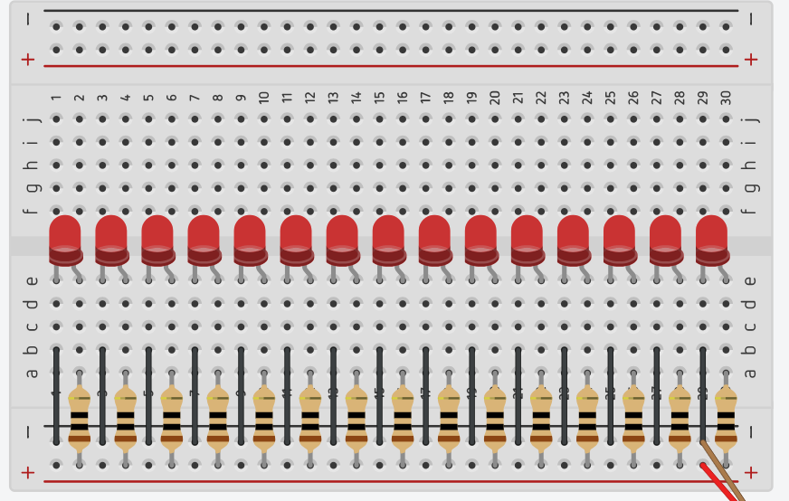

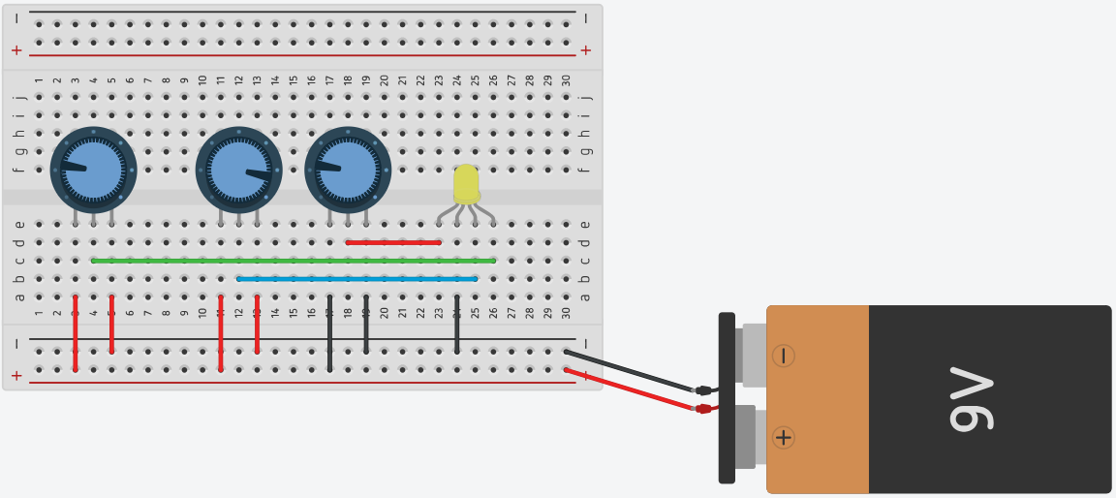

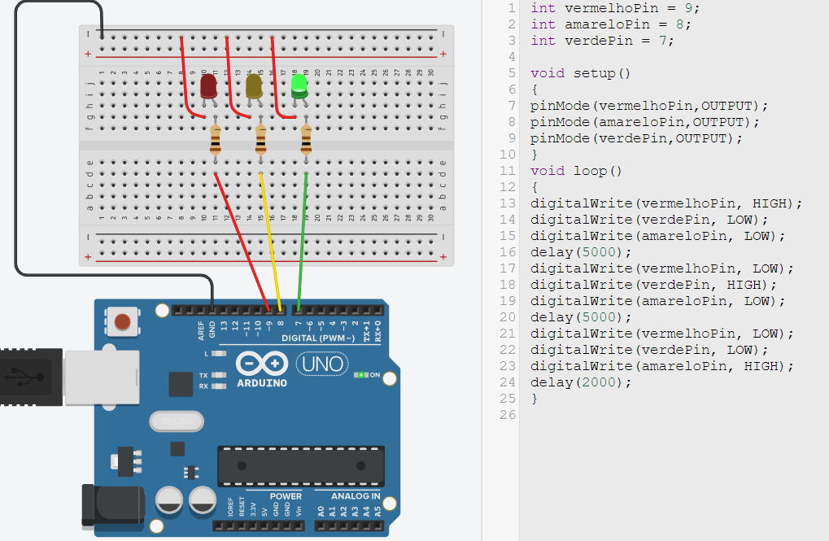

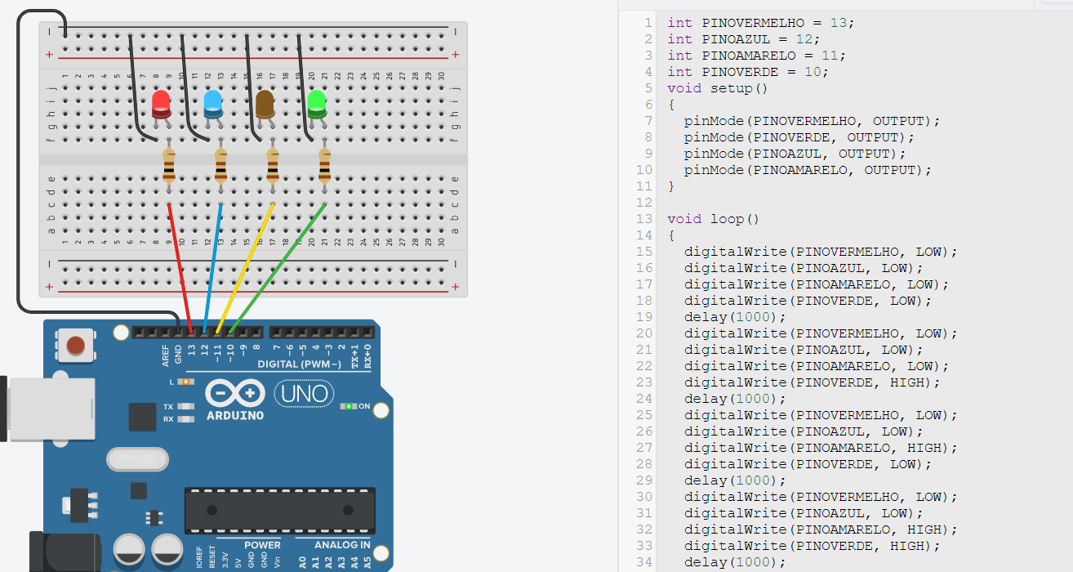

int PINOVERMELHO = 13;

int PINOAZUL = 12;

int PINOAMARELO = 11;

int PINOVERDE = 10;

void setup()

{

pinMode(PINOVERMELHO, OUTPUT);

pinMode(PINOVERDE, OUTPUT);

pinMode(PINOAZUL, OUTPUT);

pinMode(PINOAMARELO, OUTPUT);

}

void loop()

{

digitalWrite(PINOVERMELHO, LOW);

digitalWrite(PINOAZUL, LOW);

digitalWrite(PINOAMARELO, LOW);

digitalWrite(PINOVERDE, LOW);

delay(1000);

digitalWrite(PINOVERMELHO, LOW);

digitalWrite(PINOAZUL, LOW);

digitalWrite(PINOAMARELO, LOW);

digitalWrite(PINOVERDE, HIGH);

delay(1000);

digitalWrite(PINOVERMELHO, LOW);

digitalWrite(PINOAZUL, LOW);

digitalWrite(PINOAMARELO, HIGH);

digitalWrite(PINOVERDE, LOW);

delay(1000);

digitalWrite(PINOVERMELHO, LOW);

digitalWrite(PINOAZUL, LOW);

digitalWrite(PINOAMARELO, HIGH);

digitalWrite(PINOVERDE, HIGH);

delay(1000);

digitalWrite(PINOVERMELHO, LOW);

digitalWrite(PINOAZUL, HIGH);

digitalWrite(PINOAMARELO, LOW);

digitalWrite(PINOVERDE, LOW);

delay(1000);

digitalWrite(PINOVERMELHO, LOW);

digitalWrite(PINOAZUL, HIGH);

digitalWrite(PINOAMARELO, LOW);

digitalWrite(PINOVERDE, HIGH);

delay(1000);

digitalWrite(PINOVERMELHO, LOW);

digitalWrite(PINOAZUL, HIGH);

digitalWrite(PINOAMARELO, HIGH);

digitalWrite(PINOVERDE, LOW);

delay(1000);

digitalWrite(PINOVERMELHO, LOW);

digitalWrite(PINOAZUL, HIGH);

digitalWrite(PINOAMARELO, HIGH);

digitalWrite(PINOVERDE, HIGH);

delay(1000);

digitalWrite(PINOVERMELHO, HIGH);

digitalWrite(PINOAZUL, LOW);

digitalWrite(PINOAMARELO, LOW);

digitalWrite(PINOVERDE, LOW);

delay(1000);

digitalWrite(PINOVERMELHO, HIGH);

digitalWrite(PINOAZUL, LOW);

digitalWrite(PINOAMARELO, LOW);

digitalWrite(PINOVERDE, HIGH);

delay(1000);

digitalWrite(PINOVERMELHO, HIGH);

digitalWrite(PINOAZUL, LOW);

digitalWrite(PINOAMARELO, HIGH);

digitalWrite(PINOVERDE, LOW);

delay(1000);

digitalWrite(PINOVERMELHO, HIGH);

digitalWrite(PINOAZUL, LOW);

digitalWrite(PINOAMARELO, HIGH);

digitalWrite(PINOVERDE, HIGH);

delay(1000);

digitalWrite(PINOVERMELHO, HIGH);

digitalWrite(PINOAZUL, HIGH);

digitalWrite(PINOAMARELO, LOW);

digitalWrite(PINOVERDE, LOW);

delay(1000);

digitalWrite(PINOVERMELHO, HIGH);

digitalWrite(PINOAZUL, HIGH);

digitalWrite(PINOAMARELO, LOW);

digitalWrite(PINOVERDE, HIGH);

delay(1000);

digitalWrite(PINOVERMELHO, HIGH);

digitalWrite(PINOAZUL, HIGH);

digitalWrite(PINOAMARELO, HIGH);

digitalWrite(PINOVERDE, LOW);

delay(1000);

digitalWrite(PINOVERMELHO, HIGH);

digitalWrite(PINOAZUL, HIGH);

digitalWrite(PINOAMARELO, HIGH);

digitalWrite(PINOVERDE, HIGH);

delay(1000);

}